When 00:00 GMT comes, observe the opening price at that time. This picture shows a range of +/- 30 pips in relation to the opening price. You can experiment with any range you want. For example, if the market is quiet and not quite making +/-30 pips in either direction then you can choose +/-15, 20, or 25. This is up to you.
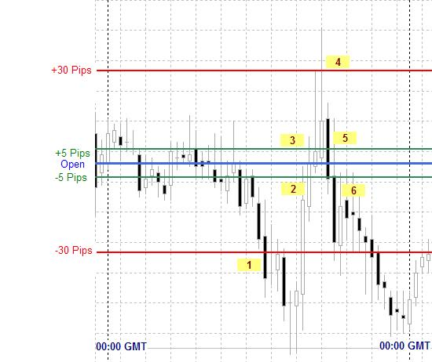

Here's what the numbers mean:
1. The price just crossed the 30 pip outer limit. This is your signal to put in a buy entry order with the following parameters:
Entry price = Open - 5 pips
Take Profit (limit) = Open + 5 pips
Stop Loss = whatever you feel is appropriate
2. The price hits your entry price and a trade is entered.
3. The price hits your take profit price and the trade is closed.
-- OPTIONAL RE-ENTRY (MORE RISK) --
4. The price has just hit the 30 pip outer limit. This is your signal to put in a sell entry order with the following parameters:
Entry price = Open + 5 pips
Take Profit (limit) = Open - 5 pips
Stop Loss = whatever you feel is appropriate
5. The price hits your entry price and a trade is entered.
6. The price hits your take profit price and the trade is closed

